GMAIL SOFTWARE

# For New Users

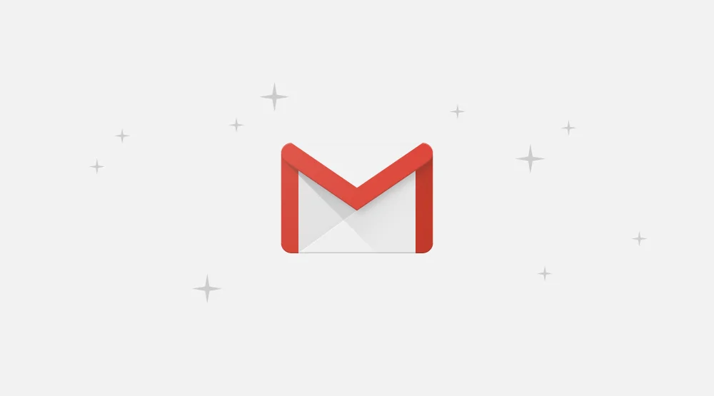

Overview: Gmail is a free email service that google offers its users an online platform from their browser. Here we will explain how to create Gmail and the setup of Gmail in addition to the Features and Settings within this email software. Many users use a Gmail account to access their emails on desktop computers and mobile devices.

# TABLE OF CONTENTS

1. Creating Gmail Account
2. Working with Gmail Account
3. Settings and Features

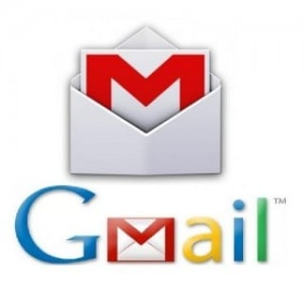

[This Photo](https://blog.dnevnik.hr/gmaillogin) by Unknown Author is licensed under [CC BY-SA](https://creativecommons.org/licenses/by-sa/3.0/)

CREATING GMAIL ACCOUNT

To create a Gmail Account, click on the [Gmail](https://mail.google.com/mail/) Icon (refer to A.1) top right-hand corner of the Google Homepage.

Here you will fill in the First name, Last name, Username, and Password. Click the next icon at bottom of the screen.

Another page will appear that allows you to enter recovery Information. Enter your phone number, recovery email address, and your Birth-date and gender.

This YouTube video shows how to create a Gmail account for new users.

[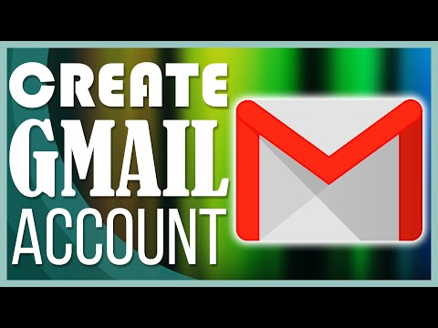](https://www.youtube.com/embed/1aUTqoiECJE?feature=oembed)Creating a Gmail account allow google users to hav

Working in Gmail

Once you have completed the information click next which brings you to the [Gmail](https://mail.google.com/mail/) interface page as shown below.

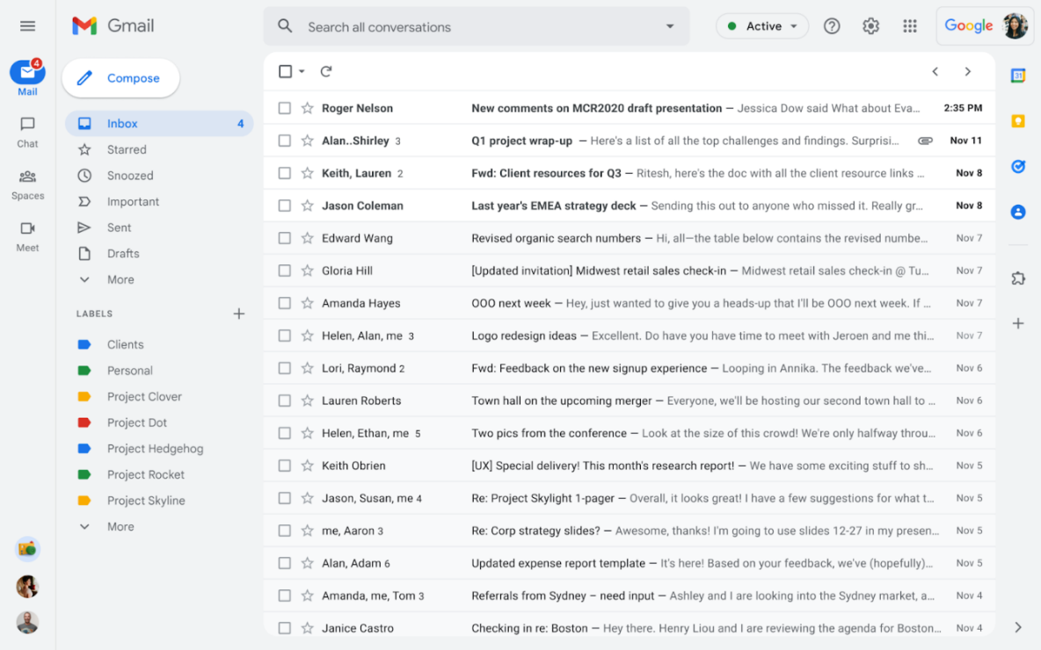

The video shows the interface and the shortcuts with Gmail

Settings and Features



